Exciting Opportunity:
Seed funding to get your Accessible Instrument designs off the ground!
We are thrilled to announce that applications are now open for our Accessible Instrument Development Funding programme, supporting the creation of new accessible musical instruments!

About the Accessible Instrument Development Funding
At DMLab we are proud to have supported several new accessible instrument designs that help to overcome barriers faced by Disabled musicians.

We want to continue supporting makers with ideas for new accessible devices. We are therefore offering two seed funding grants of £1,000 each to support the development of brand new accessible musical instruments!

This is an incredible chance for innovators and makers to get your ideas off the ground and create something new to showcase at our future DMLab events.

Who Can Apply?
We welcome applications from all creative minds, whether you’re an individual maker or part of a team. It doesn’t matter if you’re a Disabled or Non-Disabled musician, an instrument maker, or a developer – your ideas are invaluable to us. We are specifically seeking Expressions of Interest from those with innovative concepts aimed at addressing specific access requirements for yourself or others.
You must be over 18 and based in England to apply.

How to Apply
To register your interest, simply complete the short Expression of Interest form along with our Equal Opportunities monitoring form.
You can also submit answers in audio or video format if that is more accessible for you.
The Expression of Interest form will give you the opportunity to introduce yourself briefly, describe your proposed instrument, and outline the access requirement it aims to fulfil. There is space to provide links to your previous work as well as upload any sketches or images of your idea.
Applications will open on Wednesday, 16th September 2026. The deadline for submitting your Expression of Interest is Wednesday, 14th October 2026, 5:00pm.
If you have any questions about this opportunity or require support to make an application, please email Geo Aghinea at info@drakemusic.org.
We are looking forward to receiving your applications and supporting your creative journey to make music more inclusive and accessible for everyone.

What Happens Next?
- Wednesday 14 October: Deadline for expressions of interest
- Wednesday 4 November: We’ll let you know if you’ve been shortlisted
- Friday 20 November: Meetings with shortlisted applicants
- Monday 23 November: We’ll let you know if you’ve been selected

Once you have submitted your expression of interest, we will reply as soon as we can, to acknowledge that we’ve received it. We appreciate that a lot of time and effort goes into submitting an expression of interest.

Selection Panel

Tim Yates (he/him)

Tim is an award-winning instrument developer, sound artist, musician and technologist. He is Research and Innovation Executive at Drake Music, leading the development of AMIC and the organisation’s instrument R&D programme. Tim is also co-founder of Hackoustic and a PhD researcher at the University of Greenwich, exploring immersive interactive sound installations.
Image Description: Headshot of Tim Yates. Tim is a white man in his forties, with shoulder length brown hair and a beard. He’s wearing a yellow jumper.

Cheryl Hui (sher/her)
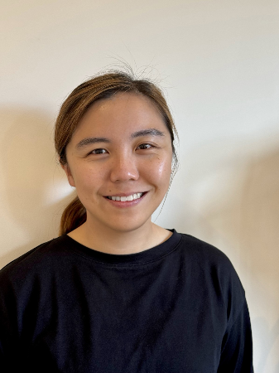
Cheryl is a musical instrument designer, musician and NIME-published researcher dedicated to challenging ableism in music. A 2025 Accessible Instrument Development Fund grantee, she co-designed the Joy of Sound Music System, a modular, kinetic instrument enabling disabled musicians to experience inclusive group music-making.

Image Description: A portrait of a smiling Asian woman wearing a black long-sleeved top against an off-white background.

Billy Payne (he/him)

Billy is a music facilitator, creative technologist and instrument designer. He co-founded Billy & Andy’s Music School, providing music activities for disabled and neurodivergent people across Manchester. A 2025 Accessible Instrument Development Fund grantee, he developed the Triochord, an accessible zither inspired by a 1970s design.

Image Description: Black and white head and shoulders portrait of a smiling man with wavy, medium length hair, round dark-framed glasses, and a short beard. He is wearing a plain t shirt and facing the camera against a plain background.

Looking for inspiration?
Check out the links below:
Blogs and videos from our 2025-26 Grantees
Blogs and videos from our 2024-25 Grantees
Our 2023-24 Grantees presenting their instruments at DMLab London
Previous news about instruments and projects we’ve been involved with
Information about our accessible musical instrument collection

About DMLab
DMLab is a project for Disabled and Non-Disabled musicians, technologists, and makers to come together and explore accessible music making. We hold regular meetups and events to help build more inclusive music making opportunities.
DMLab London is supported with public funding from Arts Council England.
Sign up to our mailing list here

