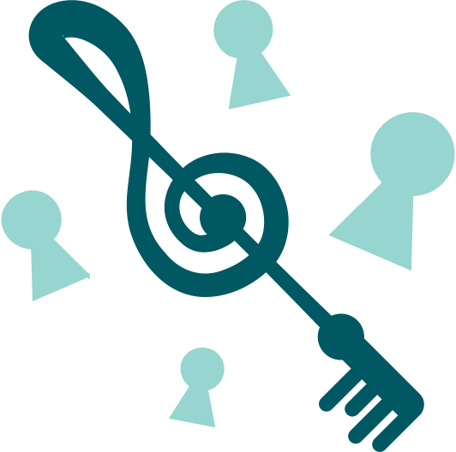

What is Inclusion?

Making Music is the Key

Large Text
Index
Introduction 1
Foreword 4
Process of Development 6
Being bold and radical 8
4 Principles of Inclusion 10
Belonging 11
Understanding 11
Participating and Contributing 12
Value and Achieving 13
All means all! 14
What’s next? 16

Introduction
Think22, and its predecessor Think2020, were Youth Music funded strategic programmes of work that helped to bring inclusive practice to the fore in music education in England. They focused on:
- Advocacy and campaigning for inclusive practice and addressing underrepresentation of Disabled People*
- Workforce development across the sector
- Delivery of inclusive music sessions in schools and other learning settings for children and young people.
This document, one of a series of four resources, was developed as part of the Think22 programme, working with our four core partners: Essex Music Education Hub, Newham Music, THAMES (Tower Hamlets Arts and Music Education Service), and Coventry Music. These resources are a reflection of Drake Music's core organisational approach of Disabled and Non-Disabled educators, musicians, leaders, artists and practitioners working together.
There is a need for more Disabled leaders, musicians, and educators in the music education sector: Think22 and Think2020 started from the position that as we are working in an environment where Disabled People are underrepresented, there needs to be action to bring about change.
These resources were created to address these needs and ensure conversation and action continues in the music education sector.
Think22 resources to explore:
- What is Inclusion? Making Music is the Key (this document)
- Supporting Inclusion - Taking positive action in your organisation
- 9 Competencies of Inclusive Music Practice - What does Inclusive Music-Making look like in Practice?
- Let's Make Music - Fun musical activities for young musicians to learn about tempo, rhythm, melody, and turn-taking
* The following words and phrases are capitalised as they represent a movement or community: Disabled People, Non-Disabled People, Disability Equality, and Inclusion.

Foreword
Inclusion is an important principle that can mean different things to different people and organisations. We wanted to be clear as an organisation as to what Inclusion means to us and how it shapes everything we do, particularly from a Disability Equality perspective.
We take a rights-based approach to disability that understands the importance of equality and the role of the Social Model of Disability in how we work, embed access and transform our experiences as we work together. Inclusion as a journey is about ensuring we do things differently.
Disabled People have experienced exclusion in society through time which led to the recognition that Disabled People are discriminated against in all areas of life.
The response to this was the fight for equality and rights for Disabled People. This new understanding of disability was transformed by Disabled People themselves through the Social Model of Disability which focuses attention on the structural and systematic barriers that exclude people.
The principles in this document are about exploring the values and beliefs that underpin what Inclusion looks like.

John Kelly, Musician & Drake Music Associate Musician

Process of Development
Purpose
This paper began life as an internal Drake Music discussion document. Its purpose is to pull together our current knowledge, experience, understanding and practice of Inclusion, particularly in the context of music education and Drake Music’s practice, and will continue to evolve over time.

We got here through:
starting points... bullet points... messy words... concepts... messy thoughts... gems of clarity... pictures... poems... a journey… expression of important values and beliefs... mistakes are fine when we learn from them... music... searching for change and opportunity... anything that is missing that it is felt needs to be said... non-prescriptive... missing voices... listening... really listening... action... always trying to be free from jargon (jargon is power)

The aims of this document are:
- To explore key thoughts around Inclusion
- To create a shared understanding of what Inclusion means in the things we do
- To build shared experiences and understanding that will help Inclusion to grow and be a reality in everything we do, so we all own it
- To create change.

Context
Drake Music has been music-making with Disabled and Non-Disabled People for a long time. We believe everyone has the right to make music and that music technology can be a great tool in music-making.
Since 2015, Drake Music has been on a journey about how we work and what changes still need to happen so that everyone can make music, as equals, for fun and enjoyment, learning, and a career.

Being bold and radical
The changes we want mean being bold and radical to challenge things that haven't changed, like:
- Understanding a different way of viewing disability – The Social Model
- Addressing representation and leadership so more Disabled People are in positions of power and control
- Understanding that Inclusion is about pace, space and having real choices and control. For example, things being led and designed by Disabled People, and not assuming Disabled People will just “fit in” to things that have been created without involving them
- Valuing access as everybody’s responsibility
- Celebrating our unique talents in music-making by immersing everything we do in this way of thinking and doing
- Considering power, listening to different and under-represented perspectives
- Being valued so we all have the equal opportunity to flourish and reach our potential, both individually and collectively
- Knowing that all these things need to lead to Inclusion in action.

4 Principles of Inclusion
- Belonging
- Understanding
- Participating and Contributing
- Value and Achieving

Belonging
- A feeling of being comfortable
- It feels right to be here
- Others have actively thought and welcomed you
- You can be yourself
- Creativity

Understanding
- Verbal and non-verbal dialogue/conversation/experiences
- Signs that your needs and aspirations are taken seriously
- You can say what you need to say
- You will be asked how you want things rather than it be assumed
- Our differences and our cultures are important to how we can belong and be ourselves
- Listening and learning from each other
- Unpacking what diversity and equality means in practice: learning, practising, we all need to be active in ensuring equality, participation and Inclusion
- The importance of creativity to get out of the box

Participating and Contributing
- Active choices and control
- Pace and space
- We will choose how and what we want to do to be a part of music-making/decision-making
- We have the space to find our way to participate/contribute
- We have control over pace so our needs are met and so we can contribute well, succeed and achieve things together as equals
- Authentic
- Feeling real
- Having fun and enjoyment
- Doing things that celebrate and reflect our culture and passions
- Creativity

Value and Achieving
- A recognition of what we have achieved
- Personal acknowledgement, growth, confidence, esteem
- The difference and change that has happened
- Our experience, contribution and learning
- Reward from acknowledging how we feel and what that does to us, right through to formal recognition and value

All means all!
Inclusion is about change, equality, access and action. It is resolute and strong, but how it is realised depends on the people involved and the context and resources given to make it a reality.
Nothing about us without us.
Inclusion is an emotional connection too, like being in a band; I feel I belong, I feel valued, I feel happy, I feel I’ve done good, I feel I need to learn more, I feel success...
Everybody’s journey is different. Working together, it is important to build shared understanding to address inequality.
We found it important to reflect on what we do much more through the prism of:
- Our values, beliefs and attitudes
- Access and equality
- The Social Model of Disability
- Representation and leadership
- Our working practices and cultures
- Creativity
- A power shift
- Collaboration (working together)
- Social Justice
- Bringing about change
From this reflection and learning comes planning and implementing things to bring about real change.

What’s next?
- What’s missing?
- How can you change/input so this is useful to you?
- What change will this make?
- What will that change look like?
- What other questions need to be asked?
- Who else needs to be heard?

This document needs to be seen, felt, experienced, ripped up and re-created, whilst holding onto the principles that it is about:

Change, Equality, Rights, Creativity, Access and Action.

Making Music is the Key!

